

**System Development Proposal**

**Submitted by:**

**Prototype Nexus: -**

K. H. D. Gunawardhana - 14508

W.G.T.K. Wijesinghe -14506

S. H. I. Madhushan - 14504

Kamalendran Lohishan - 14503

M.A.R. Fathima Fahama - 11132

**Date:** 12.09.2023

---**TABLE OF CONTENTS---**

1. EXECUTIVE SUMMARY 3

2. INTRODUCTION 4

3. OBJECTIVES 5

4. OVERVIEW 7

5. FUNCTIONS & RESPONSIBILITIES 8

6. TIMELINE 9

7. CONCLUSION 11

8. REFERENCES 13

9. APPENDIX 14

9.1 Entity-Relationship (ER) Diagram: - 14

9.2 Use Case Diagram: - 15

9.3 User Interface Mockups and Designs: - 16

9.4 Links: - 18

9.4.1 Figma: - 18

9.4.2 Draw.io: - 18

9.4.3 Balasmiq: - 18

9.5 GitHub Repository: - 19

9.6 ClickUp Project Management: - 20

9.7 Product Logo: - 21

9.8 Company Logo: - 21

9.9 Meeting Minutes: 22

**---TABLE OF FIGURES---**

Figure 1: Entity-Relationship (ER) Diagram 13

Figure 2: Use Case Diagram 14

Figure 3: User Interface Mockups and Design (Balsamiq) 15

Figure 4: User Interface Mockups and Design (Figma) 15

Figure 5: User Interface (Desktop, Mobile, Laptop) 16

Figure 6: GitHub Repository (Prototype Nexus Project) 18

Figure 7: GitHub Repository (Prototype Nexus Group Members) 18

Figure 8: ClickUp Project Management (Timeline) 19

Figure 9:ClickUp Project Management (Group Members) 19

Figure 10: Product Logo (CAREERBRIDGE) 20

Figure 11: Company Logo (Prototype Nexus) 20

# 1. EXECUTIVE SUMMARY

The job portal system is designed to simplify and improve the job search and hiring process for job seekers and employers alike. With a focus on efficiency and user-friendliness, this platform will empower job seekers to find relevant opportunities with ease, while providing employers a streamlined way to post jobs, manage applications, and connect with potential candidates. Leveraging advanced matching algorithms, the system aims to enhance the accuracy of job recommendations, ensuring that job seekers discover the most suitable positions. Real-time notifications, a user-friendly interface, and robust data security measures further contribute to an enhanced user experience. The job portal system promises to be a game-changer in the world of job recruitment, offering significant benefits to all involved parties.

# 2. INTRODUCTION

In an era characterized by digital transformation, remote work and evolving labor markets, traditional methods of job search and recruitment are undergoing a profound revolution. Welcome to our online job portal, your gateway to a dynamic and limitless world of career opportunities.

The ever-changing landscape of the job market demands a platform that is not only user-friendly but also intelligent and adaptable. Our online job portal is designed to help you navigate this shifting landscape, providing you with a seamless and efficient interface to connect with your dream job or ideal candidate.

this portal serves as a bridge between job seekers and employers. Whether you are looking for a fulfilling career or a company looking for top talent, our online job portal provides you with the following key services. We enable you to search and apply for jobs if you are a job seeker. If you are an employer, you will be able to post jobs and view or download applicant resumes/CVs.

Prepare to embark on a new era of career discovery, as we present our project proposal for the Online Job Portal that will redefine how you find your dream job or the perfect candidate, setting the stage for a brighter and more prosperous future for all.

# 3. OBJECTIVES

Below are the goals we aim to provide to job seekers and employers through the online job portals we have created.

**1. Create a User-Friendly Platform:**

* Develop a user-friendly and intuitive online job portal that is easy for both job seekers and employers to navigate.

**2. Increase Job Listings:**

* Increase the number of job listings on the platform to provide a wide range of employment opportunities to job seekers.

**3. Enhance Search Functionality:**

* Improve the search and filter functionality to allow job seekers to easily find jobs that match their qualifications and preferences.

**4. Mobile-Friendly Design:**

* Ensure that the job portal is accessible and functional on mobile devices, catering to the needs of users who prefer to access it via smartphones and tablets.

**5. Enhance Security:**

* Implement robust security measures to protect user data and prevent fraudulent activities on the platform.

**6. Analytics and Reporting:**

* Develop tools for tracking and analyzing user behavior, job posting effectiveness, and other relevant metrics to continuously improve the platform.

**7. Customer Support:**

* Provide reliable customer support services to address user inquiries and issues promptly.

**8. Feedback mechanism:**

* Create a feedback mechanism for users to provide them with information about their experience with the platform, allowing for continuous improvement.

**9. Scalability:**

* Ensure that the platform is designed to handle increasing traffic and user loads as it grows.

**10.Timeline and Milestones:**

* Define clear project timelines and milestones to track progress and ensure that the project stays on schedule.

Following are the things we expect to achieve after the system is completed and the above-mentioned services are provided.

**1. Connect job seekers and employers:**

* Facilitating the connection between job seekers and employers, helping job seekers find suitable job opportunities and employers finding qualified candidates.

**2. Effective job matching:**

* Using advanced algorithms and search features to allow job candidates to be matched with relevant job postings based on their skills, qualifications and preferences.

**3. User-friendly experience:**

* Providing a user-friendly and intuitive interface that is easy to navigate for both job seekers and employers.

**4. Mobile Accessibility:**

* Facilitating access to and operation of the Platform on mobile devices,

**5. Formal Application Process:**

* Simplify the job application process to save time and effort for job seekers while making it easy for employers to review applications.

**6. Communication Tools:**

* Offer communication tools, such as messaging systems or interview scheduling features, to facilitate interaction between job seekers and employers.

**7. Privacy and Security:**

* Ensuring the security of user data and maintaining user privacy in accordance with applicable regulations.

**8. Time Savings:**

* Save job seekers time by providing a centralized platform for job searching, eliminating the need to visit multiple job boards or company websites.

# 4. OVERVIEW

1. **User Authentication and Profiles -:**
   * Users can create accounts and log in.
   * User profiles allow for personalization and storing essential information.
   * Users can update their profile information.
   * Users view their profiles and personal information.
   * Users can delete their accounts.
   * Different user roles: Job Seekers and Employers.
2. **Job Search and Feedback and Ratings-:**
   * Job seekers can search for job listings based on various criteria like industry, salary, and job type.
   * Users can provide feedback and ratings for employers and job seekers.
   * Users can edit their feedback.
   * users can delete their feedback and ratings.
3. **Job Posting -:**
   * Employers can post job openings, providing detailed descriptions, requirements, and application instructions.
   * Job seekers can view job postings.
   * Employers can edit job postings.
   * Employers can delete job postings.
4. **Apply for jobs -:**
   * Job seekers can upload their resumes/CVs by using job portal.
   * Employers view job applications.
   * Job seekers can edit their job applications.
   * Job seekers can withdraw their job applications.
5. **Checking CVs/resumes -:**
   * Employers can view and download applicant resumes/CVs by using job portal.
   * Employers can update CV status.
   * Employers can create feedback for job seekers.
   * Employers can delete CV from the collection.

# 5. FUNCTIONS & RESPONSIBILITIES

**5.1 - K. H. D. Gunawardhana**

* The Group Leader was responsible for documentation, coding, and designing. He also handled database management and effectively presented the project.
* He is responsible for **user authentication and profiling function.**

**5.2 - W.G.T.K. Wijesinghe**

* Another Group Member, specialized in wireframing, coding, and designing. He contributed to requirement gathering and presentation preparation, as well as database.
* He is responsible for **Job posting function.**

**5.3 - S. H. I. Madhushan**

* Another Group Member, specialized in coding, designing and documentation. He contributed to the database and presentation preparation.
* He is responsible for **Job Search, Feedback and Ratings function.**

**5.4 - Kamalendran Lohishan**

* A dedicated Group Member, excelled in documentation, coding, and designing. He played a crucial role in requirement gathering and efficiently managed databases.
* He is responsible for **Apply for jobs function.**

**5.5 - M.A.R. Fathima Fahama**

* A Group Member, focused on requirement analysing, prototyping, and coding. She prepared presentations and managed test results and databases.
* She is responsible for **Checking CVs/resumes function.**

# 6. TIMELINE

Milestone 0

* Responsible by All team members.
* Preparation for the Group Project.
* 17th of August 2023

Milestone 1

Milestone 2

Milestone 3

Milestone 4

Milestone 5

Milestone 6

Milestone 7

* Responsible by All team members.
* Assignment 01 Proposal and Presentation.
* 12th of September 2023
* Responsible by All team members.
* First Meeting for assign a Group Leader.
* 19th of August 2023
* Responsible by Group Leader.
* Topic Selection.
* 19th of August 2023
* Responsible by All team members.
* Discussion meeting based on Balasmiq and Figma.
* 20th of September 2023
* Responsible by All team members.
* Assignment 02: Prototype Creation and Presentation.
* 25th of September 2023
* Responsible by All team members.
* Final Test Run.
* 20th of October 2023
* Responsible by All team members.
* Start the coding.
* 22th of September 2023

Milestone 8

* Responsible by All team members.
* Assignment 03 - Full Report and Viva.
* 25th of October 2023

# 7. CONCLUSION

The importance of a job portal site, cooperation within the team, and the expected benefits upon completion can be summarized as follows:

**1. Job Portal Site Importance:**

* Job portal sites serve as essential tools in the modern job search process, connecting job seekers and employers efficiently.
* They provide a centralized platform for job listings, making it easier for job seekers to find relevant opportunities and for employers to reach potential candidates.
* Job portals offer customization, allowing users to tailor their job searches to their specific preferences, including location, industry, and job type.
* These platforms often provide resources, career advice, and company information to aid job seekers in making informed decisions.
* The job portal site's importance lies in its ability to streamline the job search and hiring processes, saving time and effort for both job seekers and employers.

**2. The collaboration within the team:**

* **Interdisciplinary Skills:**

Collaboration often involves team members with diverse skills and expertise. Combining these skills can lead to innovative solutions and a more comprehensive approach to problem-solving. For a job portal site, this may include web developers, designers, content creators, and data analysts.

* **Regular Meetings:**

Scheduled team meetings allow for progress updates, problem-solving, and the sharing of ideas. Meetings can also help identify and address any bottlenecks or issues that may be impeding progress.

* **Collaborative Tools:**

Utilize collaboration tools and software that facilitate communication and project management. These tools can include project management platforms, messaging apps, version control systems, and shared document repositories.

**3. Expected Benefits Upon Completion:**

* **For Job Seekers:**
* Enhanced job search capabilities, including advanced filters and personalized recommendations.
* Access to a wide range of job listings from various industries and locations.
* Valuable career resources, such as resume-building tools and interview preparation advice.
* **For Employers:**
* A platform to post job listings, manage applications, and connect with potential candidates.
* Access to a diverse pool of qualified job seekers.
* Tools for efficient recruitment, including applicant tracking systems.
* Improved employer branding and the opportunity to showcase company culture.

# 8. REFERENCES

List any references or sources of information you've used in preparing this proposal.

1. **LinkedIn:** [LinkedIn](https://www.linkedin.com/)
2. **Indeed:** [Indeed](https://www.indeed.com/)
3. **Glassdoor:** [Glassdoor](https://www.glassdoor.com/)
4. **Monster:** [Monster](https://www.monster.com/)
5. **CareerBuilder:** [CareerBuilder](https://www.careerbuilder.com/)
6. **SimplyHired:** [SimplyHired](https://www.simplyhired.com/)
7. **ZipRecruiter:**  [ZipRecruiter](https://www.ziprecruiter.com/)
8. **Snagajob:** [Snagajob](https://www.snagajob.com/)
9. **Dice:** [Dice](https://www.dice.com/)
10. **Idealist:** [Idealist](https://www.idealist.org/)
11. **USAJOBS:** [USAJOBS](https://www.usajobs.gov/)
12. **Job Hunder:** Job Hunder
13. **Remote.co:** [Remote.co](https://remote.co/)

# 9. APPENDIX

## 9.1 Entity-Relationship (ER) Diagram: -

This section presents an Entity-Relationship (ER) diagram that visually represents the structure and relationships within the database of our job portal. The ER diagram offers a clear and concise overview of how different data entities are interconnected, providing valuable insights into data organization and database design.

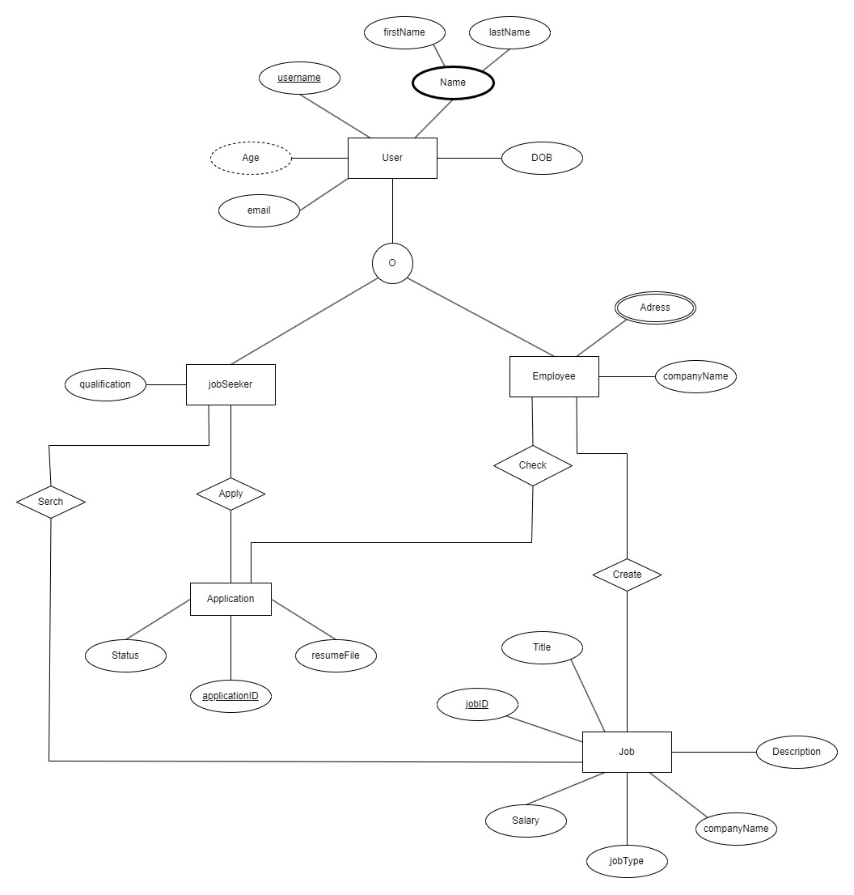

**Figure 1: Entity-Relationship (ER) Diagram**

## 9.2 Use Case Diagram: -

This section presents a Use Case Diagram that provides a visual representation of the interactions between various actors and the functionalities of our job portal system. The diagram showcases the core use cases that demonstrate how different users (actors) engage with the platform, highlighting the key features and user experiences.

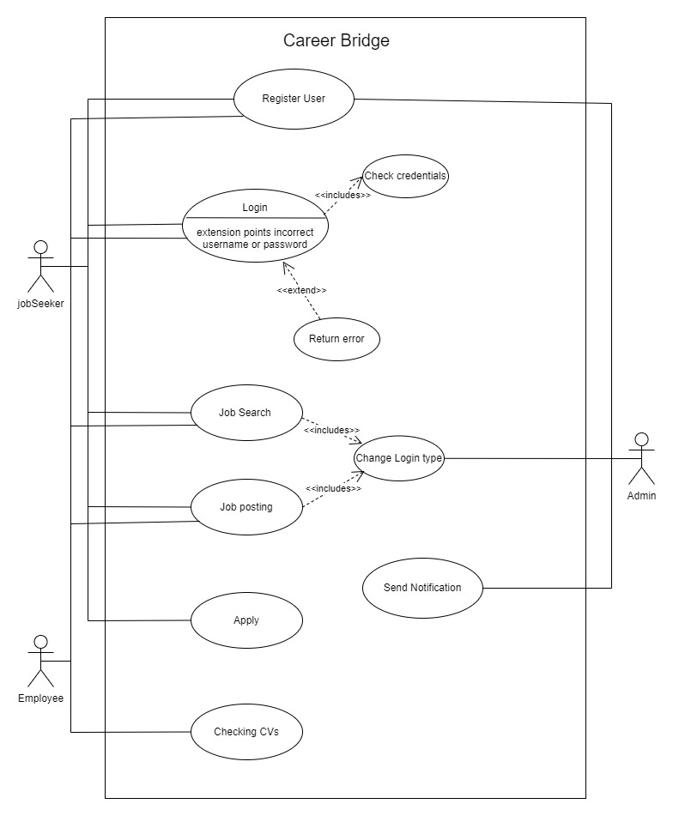

**Figure 2: Use Case Diagram**

## 9.3 User Interface Mockups and Designs: -

This section showcases the visual blueprint of our job portal's user interface. Through high-quality mockups and design representations, it offers a glimpse into the portal's aesthetics, layout, and user experience, highlighting the intuitive and engaging design elements that make our platform user-friendly and visually appealing.

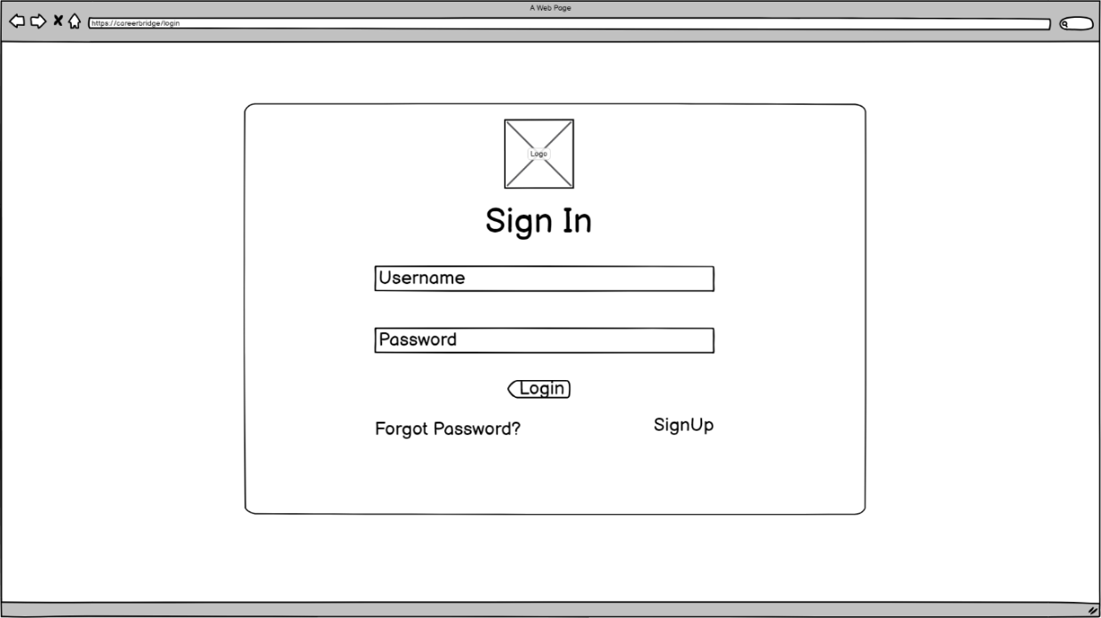

**Figure 3: User Interface Mockups and Design (Balsamiq)**

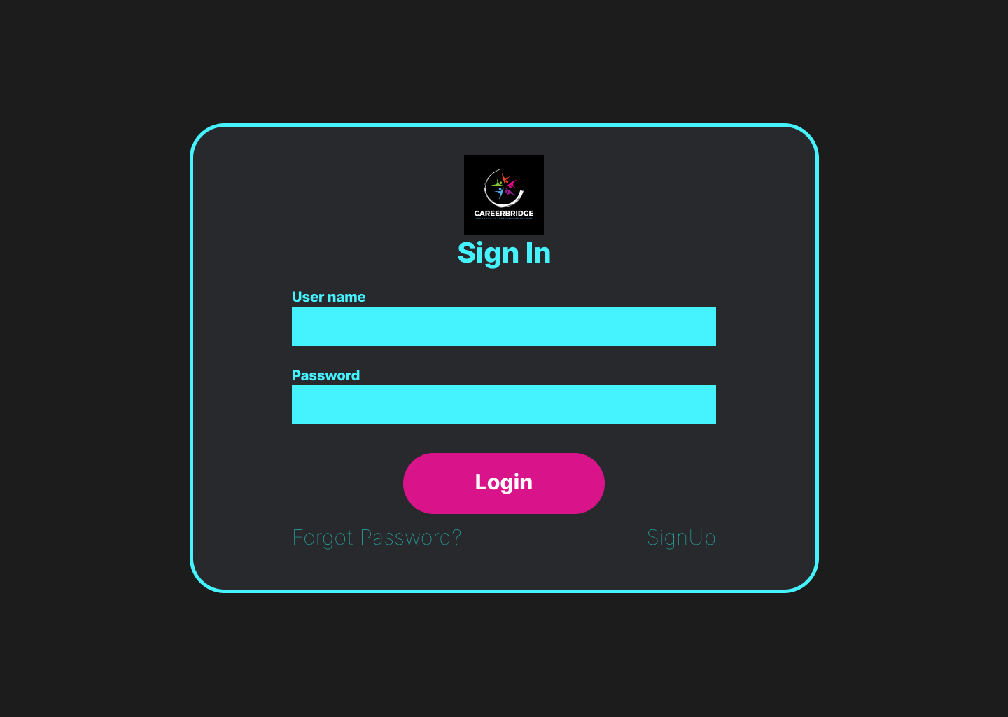

**Figure 4: User Interface Mockups and Design (Figma)**

**Figure 5: User Interface (Desktop, Mobile, Laptop)**

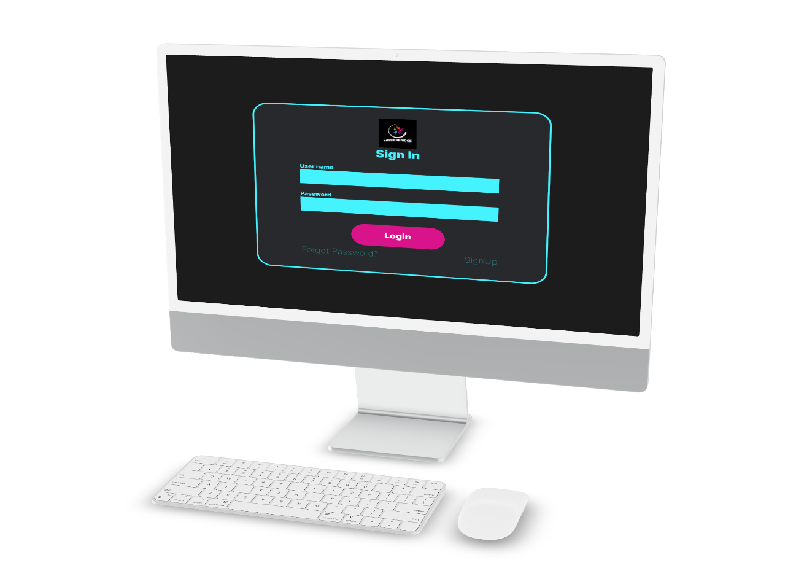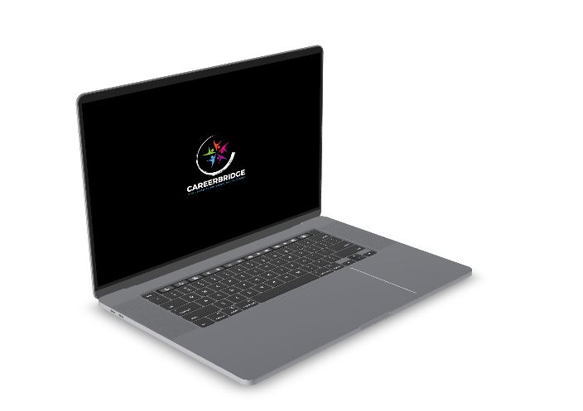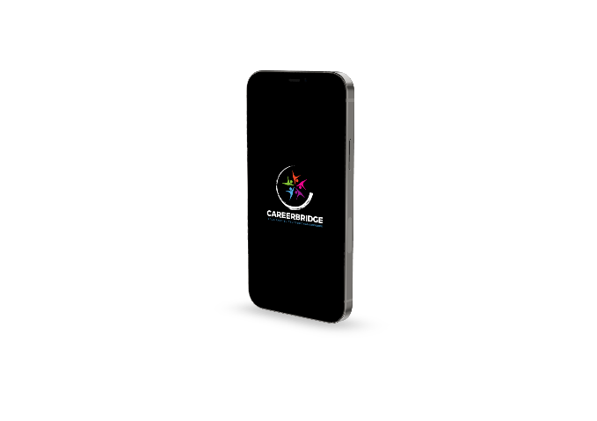

## 9.4 Links: -

### 9.4.1 Figma: -

We leverage Figma, a powerful collaborative design and prototyping platform, to streamline the development of our job portal. Figma allows our team to work seamlessly on the project's user interface design and prototype creation in a collaborative and efficient manner. This collaborative environment fosters real-time feedback, version control, and design consistency, resulting in a user-friendly and visually compelling job portal. Link to our respective project,

* <https://www.figma.com/file/Ra91d7RXhSehq4r5cE1tLs/Prototype-Nexus?type=design&node-id=0%3A1&mode=design&t=FuznNsWj7EQPUUee-1>

### 9.4.2 Draw.io: -

We utilize Draw.io, a versatile diagramming tool, to create and illustrate essential project diagrams, such as use case diagrams and entity-relationship diagrams. Draw.io empowers us to visualize complex concepts and relationships with clarity and precision. By using this tool, we enhance the understanding of our project's structural and functional aspects, making it a valuable addition to our proposal's appendix. Link to our related diagrams,

Entity Relationship Diagram

* [Prototype Nexus.drawio - Google Drive](https://drive.google.com/file/d/1WzaOf2Fv_rRCph6-wnJ07ZCWVH5IYjkx/view)

Use Case Diagram

* [prototype nexus(USD).drawio - Google Drive](https://drive.google.com/file/d/1GzB1mp5eX_QSmAUp1Wu84rZLDIxUQPCI/view)

### 9.4.3 Balasmiq: -

Balsamiq, a wireframing and prototyping tool, plays a pivotal role in our project's development. We utilize Balsamiq to create wireframes that serve as the blueprint for the user interface of our job portal. These wireframes help us outline the layout and functionality of the portal with simplicity and clarity, enabling effective communication of design ideas and enhancing the overall user experience. This appendix includes Balsamiq wireframes to provide a visual representation of our portal's design and functionality.

* <https://balsamiq.cloud/s2c6z8l/pfac5ha>

## 9.5 GitHub Repository: -

This section provides a link to our project's GitHub repository, where the source code, documentation, and development history of our job portal project are hosted. Access to the repository allows stakeholders, partners, and reviewers to explore the project's technical details and progress. Username of group members is given below.

* K. H. D. Gunawardhana -> hasarangad
* W.G.T.K. Wijesinghe -> Tharushakanishkawije
* Kamalendran Lohishan –> Lohishan2000
* S. H. I. Madhushan -> isuru-madhushan
* M.A.R. Fathima Fahama -> ffahama

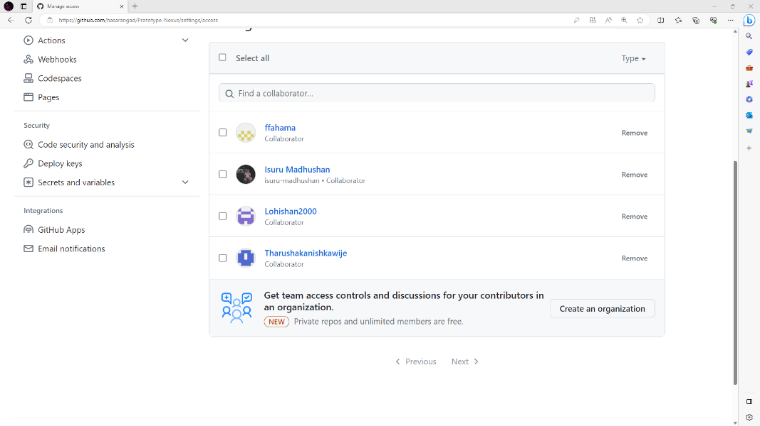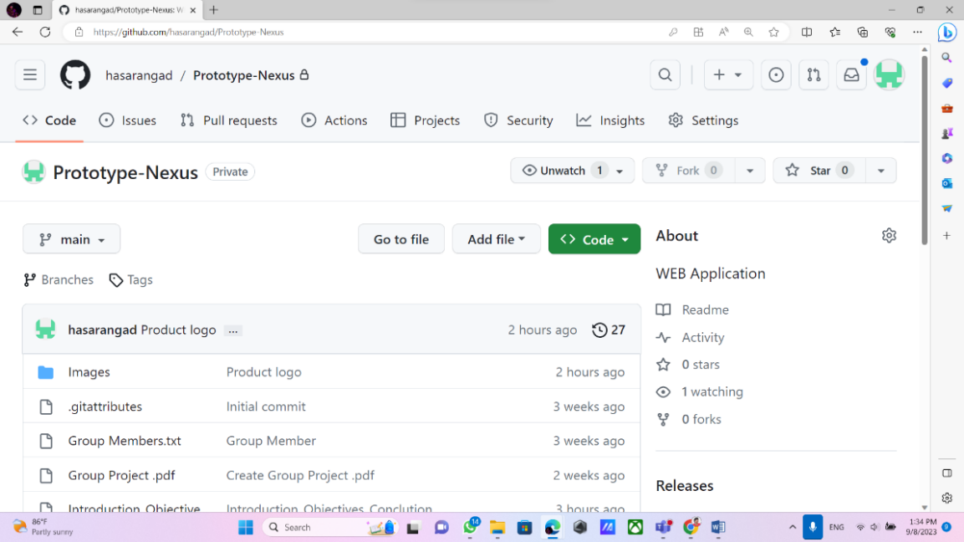

**Figure 6: GitHub Repository (Prototype Nexus Project)**

**Figure 7: GitHub Repository (Prototype Nexus Group Members)**

## 9.6 ClickUp Project Management: -

This section delves into our project timeline management processes, highlighting the central role of ClickUp as our primary tool for scheduling, tracking milestones, and ensuring project deadlines are met. ClickUp's timeline features empower us to visualize and manage the project's progress effectively. Username of group members is given below.

* K. H. D. Gunawardhana -> Keshan Hasaranga Dias Gunawardhana
* W.G.T.K. Wijesinghe -> Tharusha Kanishka
* Kamalendran Lohishan –> Lohishan2000
* S. H. I. Madhushan -> Isuru Madhushan
* 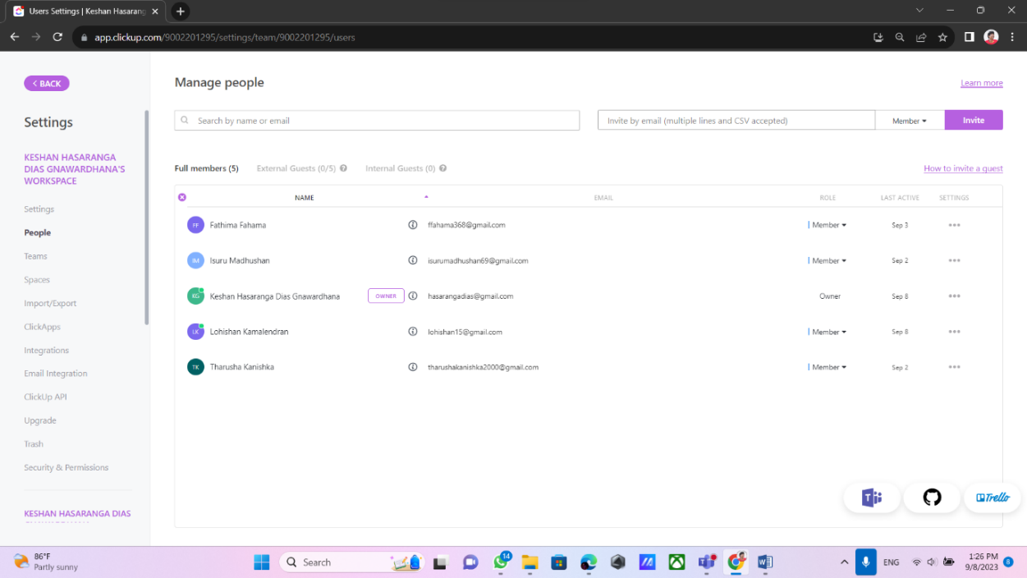M.A.R. Fathima Fahama -> Fathima Fahama

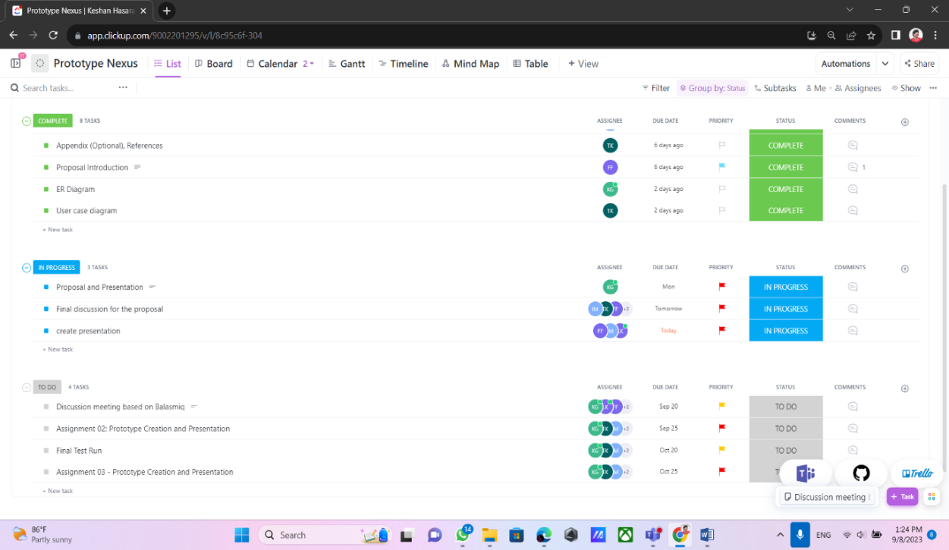

**Figure 8: ClickUp Project Management (Timeline)**

**Figure 9:ClickUp Project Management (Group Members)**

## 9.7 Product Logo: -

This product logo represents our online job portal.



**Figure 10: Product Logo (CAREERBRIDGE)**

## 9.8 Company Logo: -

This product logo represents our company.

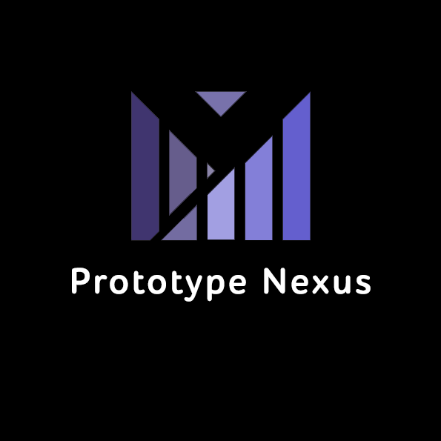

**Figure 11: Company Logo (Prototype Nexus)**

## 9.9 Meeting Minutes:

This section presents meeting minutes from key project meetings, capturing essential discussions, decisions, and action items. These records offer valuable insights into the project's progression, ensuring transparency and accountability in our collaborative efforts. Link to our Meeting Minutes,

<https://drive.google.com/drive/folders/1wsYAY1mtmpmIFdDMG7YvGp6iNJ_3OQsQ?usp=sharing>